Deployment on Flask

Name: Harshith Sakala Santhosh

Batch code: LISUM19

Submission date: 28-03-2023

Dataset used: Breast Cancer Dataset

Model Used: Logistic Regression

Steps to deploy flask application

1. Model training using Logistic Regression and Breast Cancer Dataset

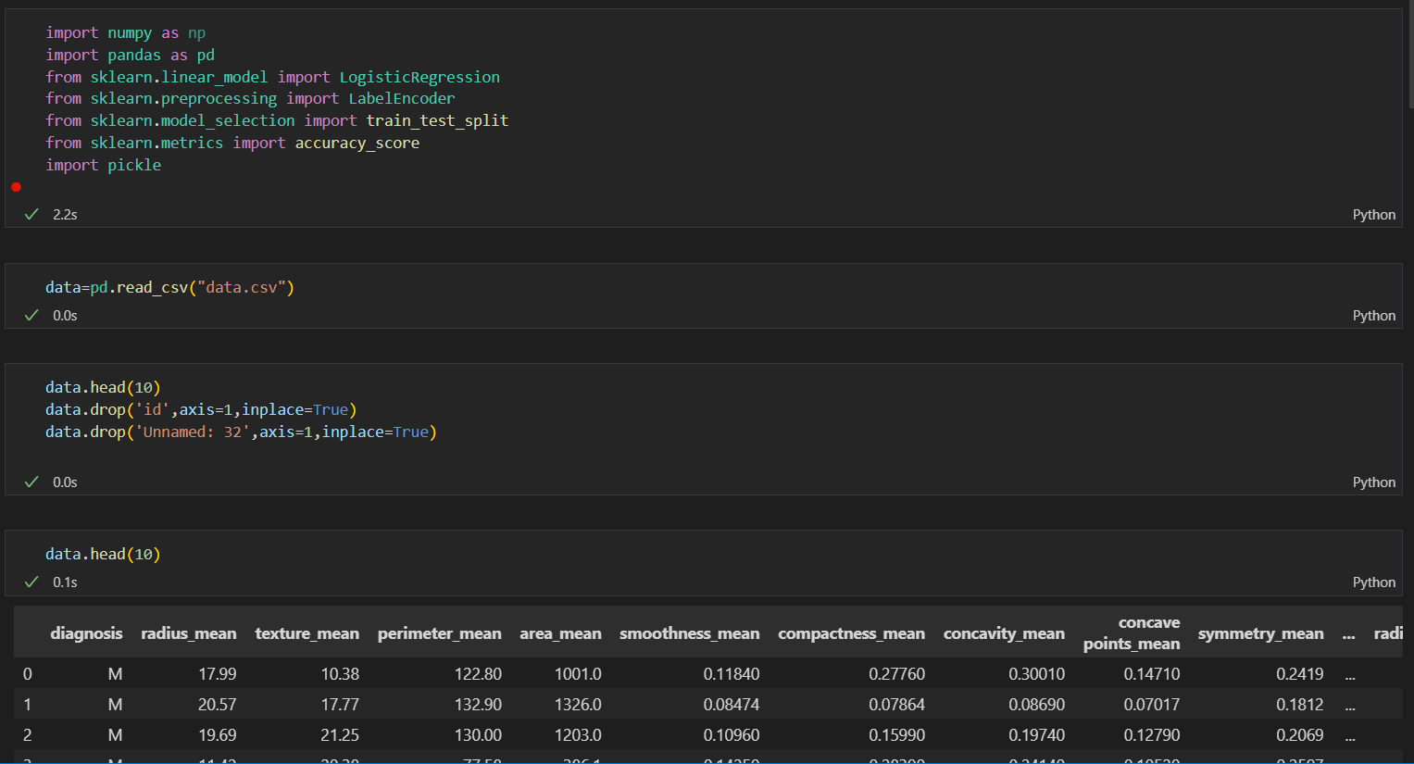

1. HTML Code and Page

1. Post-Man EndPoint:

1. Pickle file in Project Folder:

